
Case study - External Building refurbisment.doc
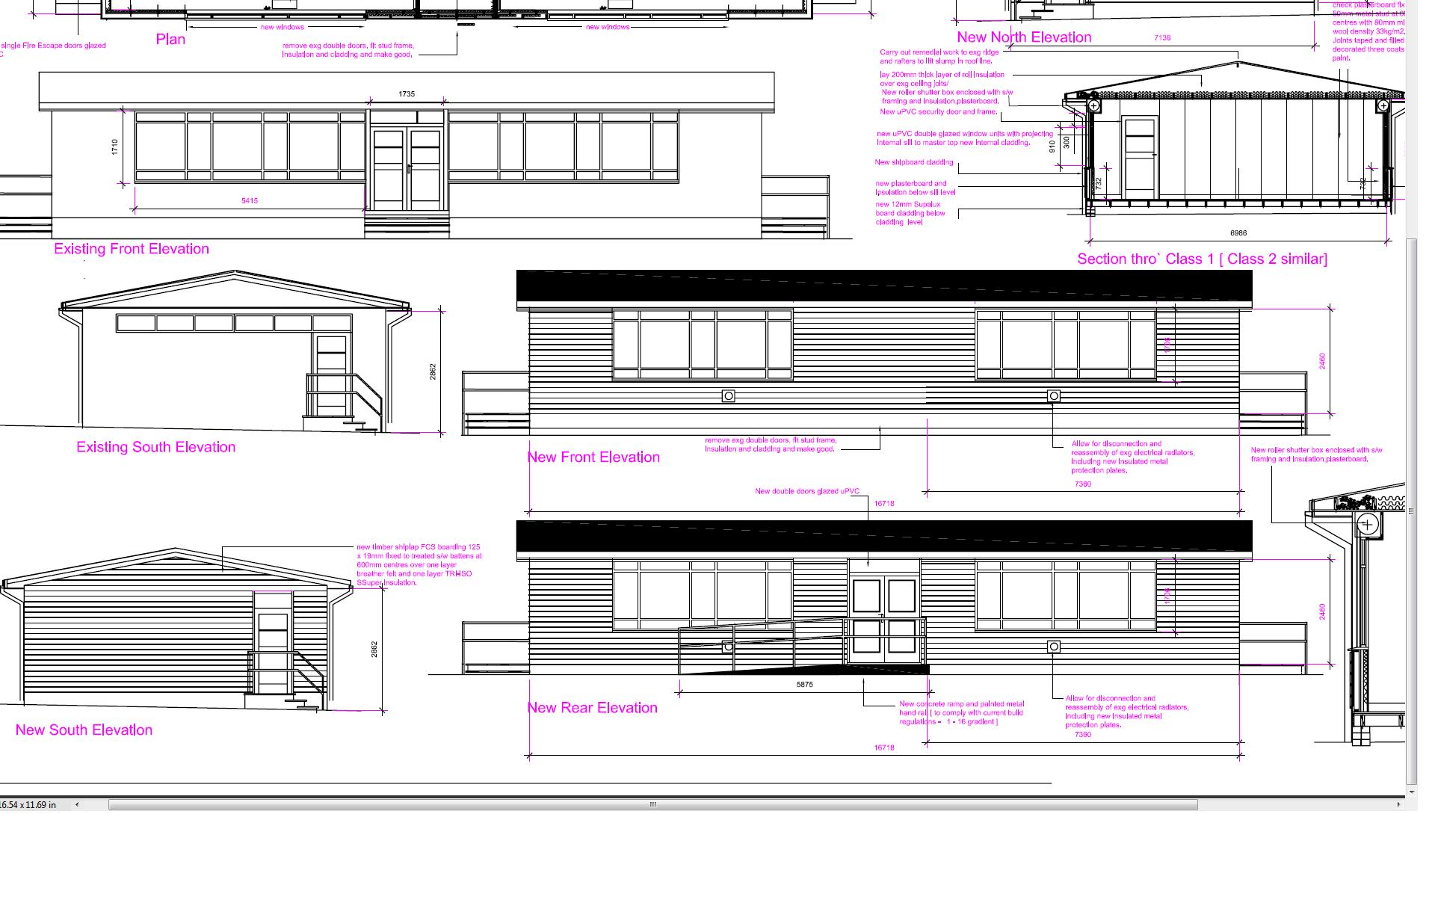
Case study – Primary School
External Building Refurbishment
Brief – Complete strip-out and upgrade of existing tempera y teaching building and bring up to modern teaching standards.
Scheme Design – Carry out structural and dimensional survey, produce full CAD working drawings, plans, sections, interior fit-out specifications, contract programme for competitive contractor quotations. Interior layouts to include new suspended ceilings, indirect lighting, integral data/power, integrated cabling for high level projectors and white board screens etc.
Scope of work – Submit drawings for building control approval; obtain specialist quotations for roller shutters, windows and electrical installation. Advise school on supplier and contractor selection.
Liaise with Site manager during construction and handover.
CAD Construction Drawings

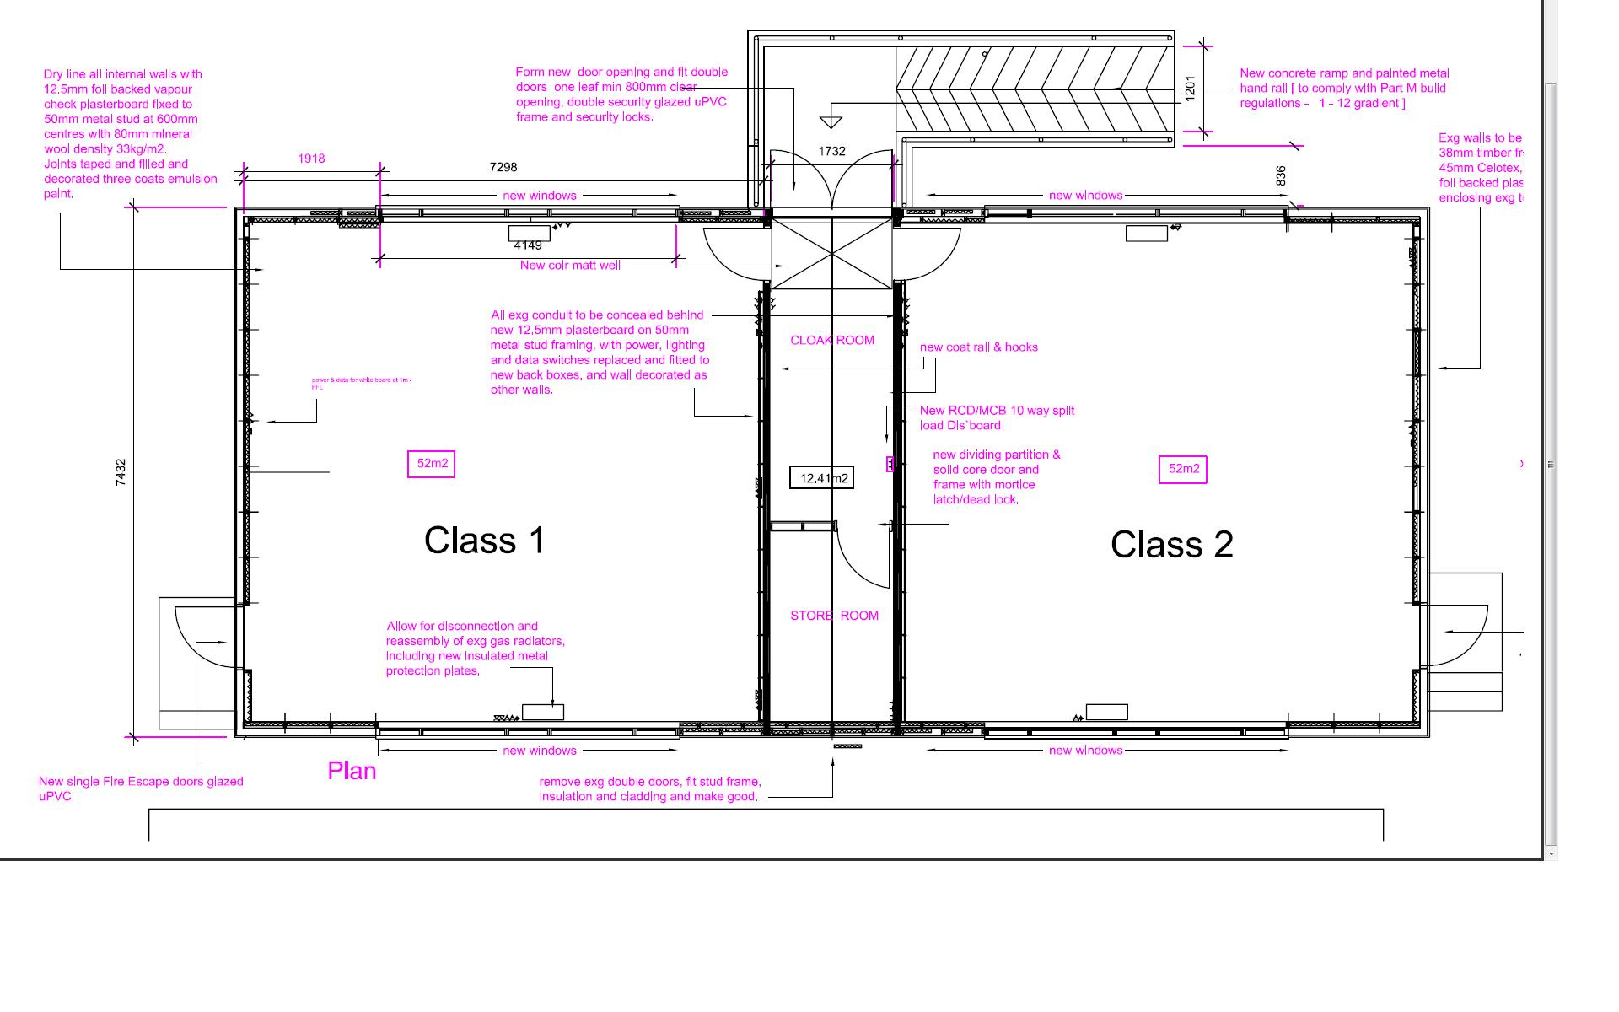
Spacedesigneurope
M: +44 [0]7710 402 457
Email: john@spacedesigneurope.co.uk
www.spacedesigneurope.co.uk

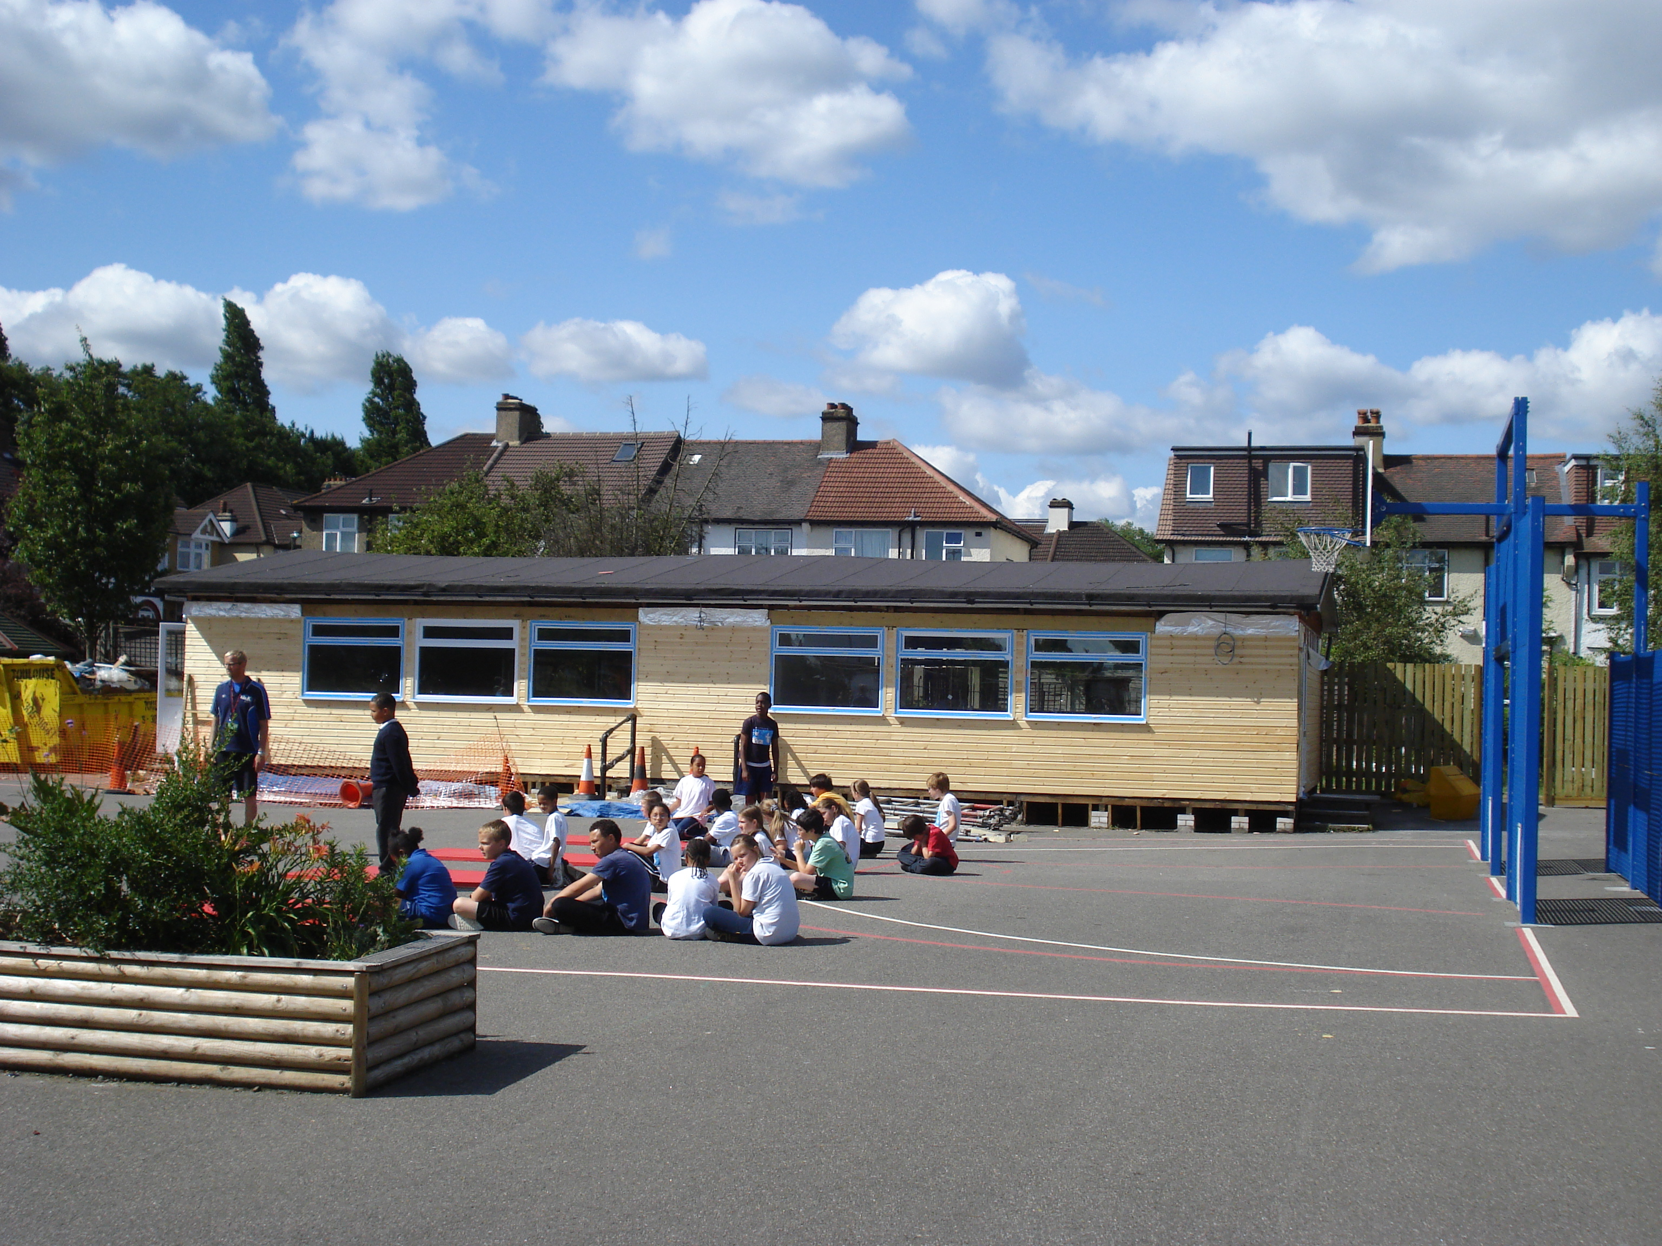
Completed Year 6 Classrooms

